Lottery Procedures 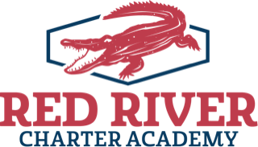

Each year new students who have no siblings presently attending RRCA, fill out a form to enter the lottery for the up-coming school term. These forms are available on the website and our FB page every year when open enrollment begins. Open enrollment for all grades begins the 2nd week of January and ends the 3rd week of April. The lottery is held live on FB and open to the public the last week of April. Specific dates are sent out to all enrollees.

Lottery numbers are assigned to all new students except those that have siblings already attending RRCA. For any grade level, when new students exceed the number of available seats the lottery is used to create a list of those who will be accepted and those that will remain on the waiting list until a seat becomes available. For example, there may be seats available in 7th grade, but not in 8th. In that instance all new students who have applied through the lottery enrollment form for 7th grade will be randomly selected by pulling assigned numbers from a bucket. All students for 8th grade will also be selected at random but put on a waiting list in the order that the student number was pulled. In the event that a seat in 8th grade becomes open, the waiting list is used to contact parents and students that they may apply for that seat.

No student is denied enrollment at RRCA based upon race, ethnicity, gender, religion, academic performance or disability. We welcome all students to apply throughout the school year as seats become available. Please call the office @ 318-409-4015 if you need further assistance.

