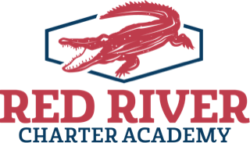
2021-2022 RRCA
6, 7, 8, 9, 10
Please circle the grade
entering in 2021-22

Enrollment for Lottery

Lottery #______________
For Office Use
Completing this form only ensures that your child will be placed into the lottery system for enrollment in the upcoming
school year. Completing this form does not guarantee acceptance into RRCA. RRCA is a free public school, open to all children regardless of race, color, religion, sex, national origin, language, or disability. Listing sibling does not guarantee that he/she will be accepted.
Please Print:
STUDENT LAST NAME: |  |  |  | STUDENT FIRST NAME:
Date of Birth: (MM/DD/YYYY) | Race: |  | Gender: |  | School student will transfer from if accepted:
Last 4 of Social Security #: |  | Who does the student live with and what is the relation to the student?
Mailing Address: |  |  |  |  |  | City, State, Zip:
Please circle all special services that your child currently receives:  Homeless LEP Migrant Speech Special Ed 504 |  |  |  |  |  | What is the primary language spoken in the home?
Is your child eligible for free or reduced lunch? (circle one) Yes No

Parent/Guardian Information:
Parent Name: | Phone Numbers: | Email Address:
Parent Name: | Phone Numbers: | Email Address:
Sibling Information:
Name: | Current Grade: | Interested in attending RRCA in the future? (Circle one) Yes No
Name: | Current Grade: | Interested in attending RRCA in the future? (Circle one) Yes No
Name: | Current Grade: | Interested in attending RRCA in the future? (Circle one) Yes No
Parent/Guardian Signature for participation in the lottery is required for all applicants:
This is to certify that as the parent or legal guardian of the above named student, I understand this application is for the lottery and does not guarantee my child will be offered a seat at Red River Charter Academy.

Parent/Legal Guardian’s Signature: _____________________________ Date: ________________________________

